How Ethernet Works (using Packet Tracer)
Below is a tutorial that takes you through a visualization of how Ethernet works. It covers concepts such as:
- Broadcasts
- Collisions
- Hubs
- Switches
- Examining Packets
- ARP and ICMP
Let’s use Packet Tracer to visualize Ethernet and how it works. Please download the files on Canvas I have configured for you (Canvas > MIS 423 > Files > HoA3 File.pkt).

Hubs
In Packet Tracer, let’s see how Ethernet operates in a shared environment where every device is on a hub. Remember, if a frame goes through a hub, it will broadcast the frame through every port that is active. Let’s see how this works by sending a frame from PC6 to PC3.
- Remember, for PC6 to be able to communicate with PC3, it must know PC3’s MAC Address. Let’s see if PC6 knows the MAC Address for PC3 by pinging it.
- Click on PC6 and open the command prompt.
- Type arp –a and press enter
- This will show us the MAC Addresses PC6 knows. It doesn’t look like PC6 knows any MAC Addresses.
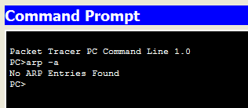
- So for PC6 to communicate with PC3, there needs to be an ARP broadcast from PC6 to ALL of the devices on the LAN so that PC6 can find the MAC Address for PC3. Let’s see how this works.
- In our workspace, Click on the Simulation Mode Icon in the bottom right hand corner of the workspace. You should be in Realtime mode, we need to be in Simulation)

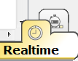 vs. 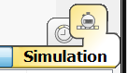

- When in Simulation Mode, click on Edit Filters and check ARP and ICMP.
- We are going to send a request from PC6 to PC3 through the Hub. PC3 will reply to PC6.
- Let’s see this in action.
- Click on the envelope icon .
- Under the Network with a Hub, click on PC6 and then on PC3. Notice the two envelopes over the PC6 icon. Your screen should look like this:
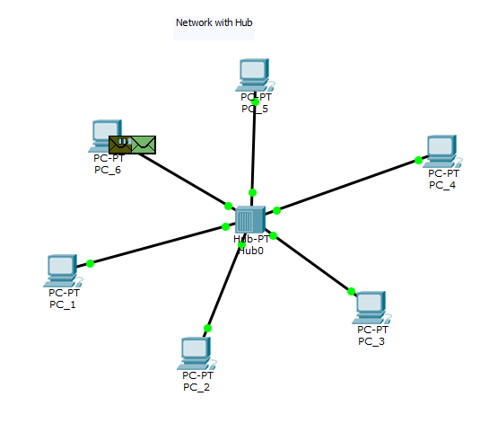
- Now when sending, the first thing to happen will be PC6 broadcasting the ARP request to the ENTIRE network through the hub. To see this, click on Capture / Forward one time. 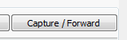
- You should see the request send from PC6 to the hub. Let’s examine the actual frame.

- Click on the green envelope on the Hub. The green envelop is the frame. We can drill into it. 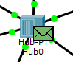

- Click on Inbound PDU Details. The screen should look like this:

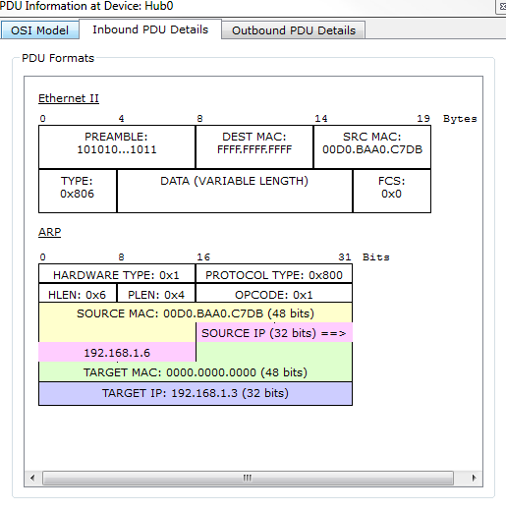

- Notice that it is an ARP frame with a Source MAC Address. Also, notice that there is no Target MAC Address but there is a target IP (I have added this for you). What else do you notice?
- The Destination MAC Address says FFFF.FFFF.FFFF. This is the designated schema for a broadcast frame. When a hub sees this, it will be broadcast the frame to the entire LAN (all of the PCs).
- Also notice the OSI Model and what layer we are at. Which layer?
- X out of this screen
- Click Capture / Forward again. You should see the frame broadcast to the entire network. Wait a second, and you should notice Red X’s on all computers but PC3. Basically the ARP request said “who has the MAC Address,” and PC3 says “I do! I do!” The remaining computers on the network drop the request.
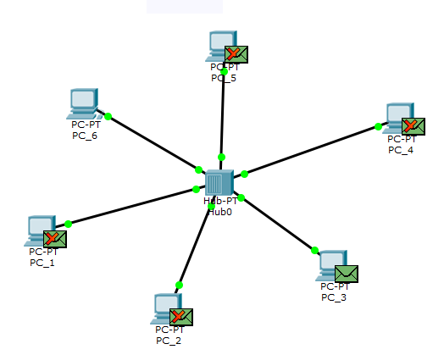

- Hit Capture / Forward again and notice that PC3 replies to PC6 through the hub.
- Click Capture / Forward again. Notice that the other PCs drop the frame and only PC6 accepted the frame.
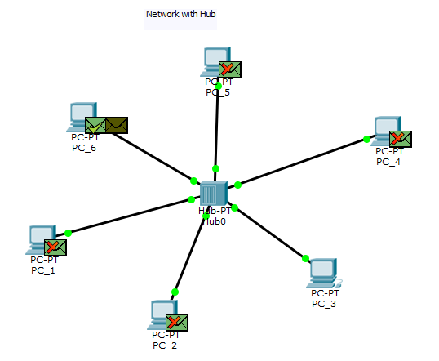
- Now we should be able to see in the command prompt that PC6 knows the MAC Address for PC3. To see this, in the command line for PC6, do an ARP request, and notice that PC6 has now learned the MAC Address for PC3.
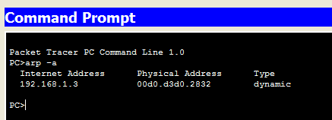

- Does PC3 know the MAC Address for PC6? Find out.

CSMA/CD in Hubs
Let’s find out what happens when to PCs send data to each other at the same time? Let’s see it in Packet Tracer.
- In simulation mode, click new Scenario 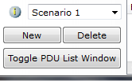
- Click Edit Filers to use ARP and ICMP
- Click the Envelope icon and click on PC6 first and then PC3. Then, click the envelope icon again and select PC4 first and then PC6. Basically, two pings are going to happen at the same time. PC6 is trying to communicate with PC3 and PC4 is trying to communicate with PC6.
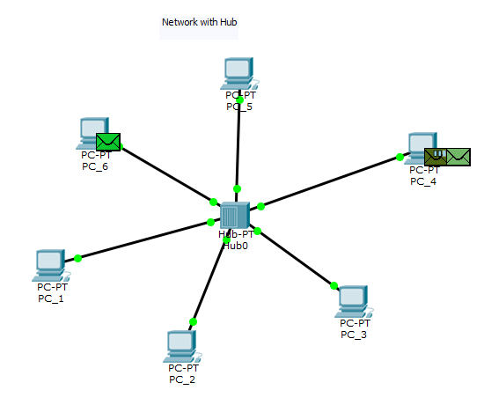
- Click Capture / Forward once and notice the frames hit the hub at the same time. What will happen next!?!?!?!?
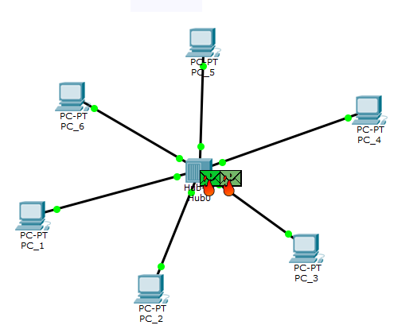
- Click Capture / Forward again. Fire! Fire!
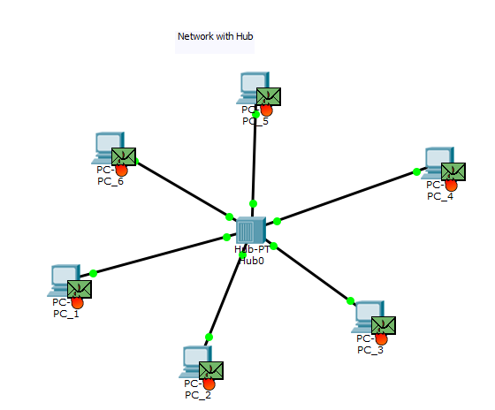

Communicating with Switches; CSMA/CD in Switches
Using the Network with Switch LAN, please complete the following steps to see what happens when using a switch and not a hub (scroll to the right in the Cisco Packet Tracer File ICA 3 File.pkt).
- In Simulation Mode, click New Scenario
- Let’s see what MAC Addresses PC6 already knows.
- Open PC6 and put in an ARP request
- You should see “no Entries Found”
- Complete a couple of steps so that PC6 knows the MAC Addresses of PC3 and PC4 (same process as before).
- Notice the differences in Hubs vs. Switches. What do you notice?
- Now, make sure that PC6 knows the MAC Addresses of PC3 and PC4 so that your ARP request command line looks like this:
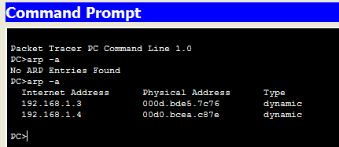

- Let’s see how collisions work
- In Simulation Mode click Edit Filers and select ARP and ICMP
- Click the envelope icon and send a Packet from PC6 to PC3, and one from PC4 to PC6.
- Click Capture / Forward and document the process. Are there frames on fire??

Overall Summary
Now that you have finished, please type a paragraph explaining what you have just accomplished by completing this tutorial. In the summary, please detail the differences when communicating between hubs and switches.

