HoA#6: Part 2 Wireless Networking
This class assignment will get you familiar with wireless networking. By the end of the assignment, you should be able to:
- Explain wireless networking and how data is transmitted over wireless networks
- Explain and discuss Wi-Fi standards
- Discuss BSSID, SSID, and ESSID
- Identify and discuss Wi-Fi channels
- Explain how Wi-Fi networks deal with collisions (CSMA/CA)
- Review several Wi-Fi Standards
- Discuss ways to secure Wi-Fi networks
- Explain some challenges enterprises are facing on Wi-Fi networks

What is a Wireless Network?
- Explain what a wireless network is in your own words.
- Instead of electrical pulses or light waves, how is data transmitted over a wireless network?
- What is the most common implementation of the IEEE 802.11 wireless Ethernet standard called?

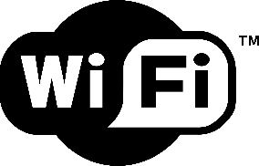
Reviewing Wi-Fi
- For fun, browse the following BuzzFeed article: http://www.buzzfeed.com/jessicamisener/what-does-wi-fi-stand-for#.ymv3aDao7p – What does Wi-Fi stand for?
- Explain how data is sent and received over a wireless network. In your explanation, include the role of wireless access points, Wireless Ethernet NICs, frames, and binary code.
- What is the role of a wireless access point? Why are wireless access points needed?
- It is important to remember that 802.11 networks operate in one of two modes: ad hoc mode and infrastructure mode.
  - Explain ad hoc mode. Give an example.
  - Explain infrastructure mode. Give an example.
  - What is the difference in IBSS, BSS, and ESS?
- What is meant by wireless networking range?

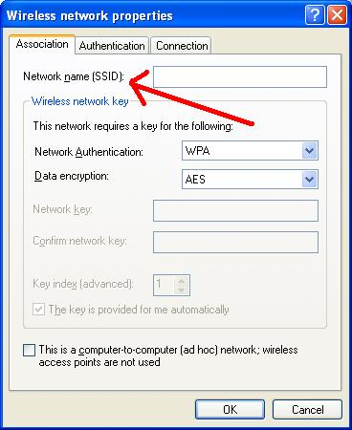
BSSID, SSID, and ESSID
Wireless devices connected together in a network, whether ad hoc or infrastructure, require a way to identify the network. In other words, frames need to go where they’re supposed to go and what network they should reside in. This is where BSSID, SSID, and ESSID, come into play.
- What is BSSID?
- What is SSID? What is the network name?
- What is ESSID? Explain roaming.

Channels
Wi-Fi networks are dependent on channels. Before answering the questions below, let’s watch this video and summarize it: https://www.youtube.com/watch?v=h6am0L9J-Yk
- Explain channels in the context of Wi-Fi networks.
- What channels do the USA use?
- Explain channel overlap and why channels 1, 6, or 11 are the most commonly used.
- Below is an image that explains channel overlap for channels 1-14. Discuss this image briefly. Note: The black semicircles are channels 1, 6, and, 11. Notice that they do not have any overlap.
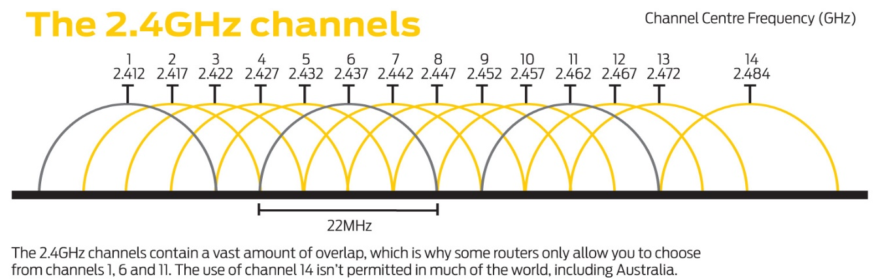

CSMA/CA
Remember CSMA/CD? A revamped version of this is used in Wi-Fi networks. Compare CSMA/CD to CSMA/CA. Why won’t CSMA/CD work with wireless networks?

Cisco Packet Tracer
Complete the following tutorials in Cisco Packet Tracer and save your file.
- Wireless Networks Part 1: https://www.youtube.com/watch?v=uB6iBSlAkIc
- Wireless Networks Part 2: https://www.youtube.com/watch?v=5jGQIRttjOM

