HoA#6 TCP/IP
This class assignment will get you familiar with the components of TCP/IP. Please answer the following questions.

Part 1: Understanding IP and TCP
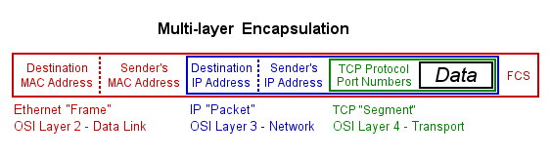
- What is Internet Protocol? What is an example of an IPv4 address? What Layer of the OSI Model is IP?
- Draw the components of an IP Packet. Draw the components of an IP header.
- What is Transmission Control Protocol (TCP)? Draw a TCP header. What Layer of the OSI Model is TCP?
- What is User Datagram Protocol (UDP)? What is the different between TCP and UDP? When would you use UDP over TCP?
- Read and summarize the first two paragraphs on page 151 in the book (about broadcasting and IP addressing).
- Discuss what is happening in the multi-layer encapsulation image above.
- Discuss what is happening in the following image: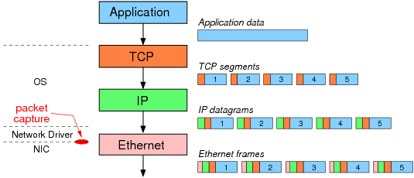

Part 2: IP Addresses, Subnet Masks, & ARP
Every TCP/IP network must have a valid network ID and that each devise on the network must have a unique host ID on that network. Using the command line, type ipconfig and fill out the following table.
IP Address
Subnet Mask
Default Gateway

- What is a Network ID?
  - What is YOUR Network ID?
  - What is YOUR host ID? What does a host ID mean?
- What is a Subnet Mask? What is the role of a subnet mask? Why is it important?
- What is a default gateway and a routing table?
- Convert the above table to binary code. To do so, locate the Windows calculator. In the calculator select View and click Programmer. The radio buttons enable you to convert between hexadecimal to binary. To convert, enter the number and then select Bin.
Your IP Address
Binary Equivalent
Your Subnet Mask
Binary Equivalent

- When you line up an IP address with a corresponding subnet mask in binary code, the portion of the IP address that aligns with the ones of the subnet mask is the network ID portion of the IP address. The portion that aligns with the zeros is the host ID. In the above table, what is the network ID in binary and what is the host ID?

- Before a computer sends out any data, it first compares the destination IP address to its own IP address using the subnet mask. If the destination IP address matches the computer’s IP wherever there’s a 1 in the subnet mask, then the sending computer knows the destination is local. The network IDs match. If even one bit of the destination IP address where the 1s on the subnet mask are different, then the sending computer knows it’s a long distance call. The network IDs do not match. Using the information below (subnet mask, computer A, and computer B), imagine Computer A is sending data to Computer B. Will the data be sent on a LAN or a WAN? How do you know? Once you know, explain the process through which Computer A sends data to Computer B.

Subnet Mask: 11111111.11111111.11111111.00000000
Computer A: 11000000.10101000.01001101.00101111
Computer B: 11000000.10101000.01001100.00110110

- ARP stands for Address Resolution Protocol. When you try to ping an IP address on your local network, say 192.168.1.1, your system has to turn the IP address 192.168.1.1 into a MAC address. This involves using ARP to resolve the address, hence its name. Systems keep an ARP look-up table where they store information about what IP addresses are associated with what MAC addresses. When trying to send a packet to an IP address, the system will first consult this table to see if it already knows the MAC address. If there is a value cached, ARP is not used. Let’s look at the ARP in our Windows machines.
  - First, what is ARP and what is its role?
  - Next, in the command line, type arp –a Press enter. You should see a table. What is this table?
  - What do you notice about the Interface address and your own IP address?
  - Using the information you found in the ipconfig exercise, what is the default gateway?

Part 3: Class IDs
- What is the function of the IANA? Why is it needed?
- Discuss the table on page 161. What is the meaning of the first decimal value, the addresses, and hosts per Network ID? See this website for more information: https://technet.microsoft.com/en-us/library/cc940018.aspx

- What class is your machine’s IP address? Why do you think that is?

Part 4: CIDR and Subnetting
- What is CIDR and subnetting? What is an example?
- Why is subnetting important?

Part 5: IP Address Assignment
- What is static vs. dynamic IP addressing?
- Describe the function of the DHCP on a TCP/IP network? How does it work?
- Let’s see if DHCP is enabled.
  - On your windows machine, go to Start > Control Panel > Network and Sharing Center.
  - Next to Connections click on Local Area Connection. Click Details.
  - Is DHCP enabled?
  - Also, what other information do you notice that you have covered in this assignment?

