HoA#3: Part 1: Ethernet Basics
In this in-class assignment, you will learn about the basics of Ethernet technology, including its history, and a great deal about what is actually happening on Ethernet networks. At the end, you will apply your knowledge to a hypothetical scenario.
To complete the assignment, please make a PowerPoint that answers all of these questions. You will present the PPT at the end of class. Feel free to work in pairs.

Part 1: A History of Ethernet
- In your own words, how would you best define and describe Ethernet?

- What topology does Ethernet typically use, and has been used since its inception in the early 1990s?

- Explain how hubs and repeaters work.

Part 2: Ethernet Frames
- What two core networking issues do frames address? Explain.

- Let’s break down the Ethernet frame: Define and explain the function of each component.
  - Preamble
  - Recipient MAC
  - Sender MAC
  - Type
  - Data
  - Pad
  - FCS

- When a computer sends out a frame, it goes into a hub. Why do you think the hub repeats an exact copy of that frame to every connect port. (hint: think about topology).

Part 3: The CSMA/CD
- Explain the CSMA/CD and its main idea.
  - What is Carrier Sense?
  - What is Multiple access?
  - What is a collision domain?
  - Explain what happens when a collision occurs and collision domain (it might be helpful to Google collision domain since the book does not go into much detail -- http://www.omnisecu.com/images/cisco-certified-network-associate-ccna/collision-domain.jpg). Should a collision domain be large? Why or why not?

Part 4:
You also may be asked how many collision domains are in a network when taking the Network+ exam. All you have to remember is that a hub expands collision domains (they make collision domains larger), and a switch breaks up collision domains. In a switch, each port represents its own collision domain.
- So, assuming the blue squares below are hubs, how many collision domains are there in the picture below?
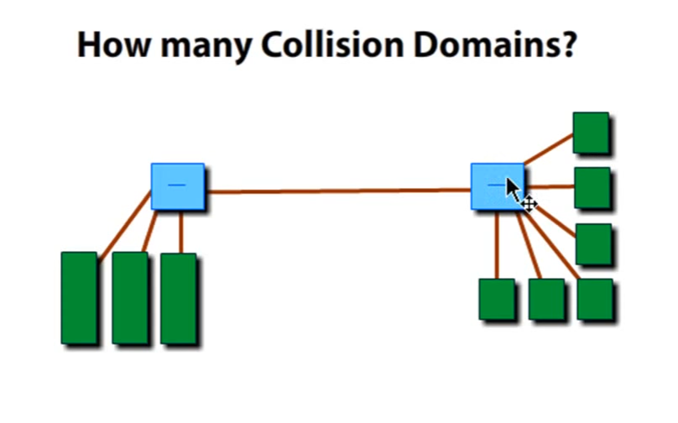

- Assuming the blue squares below are switches, how many collision domains are there?
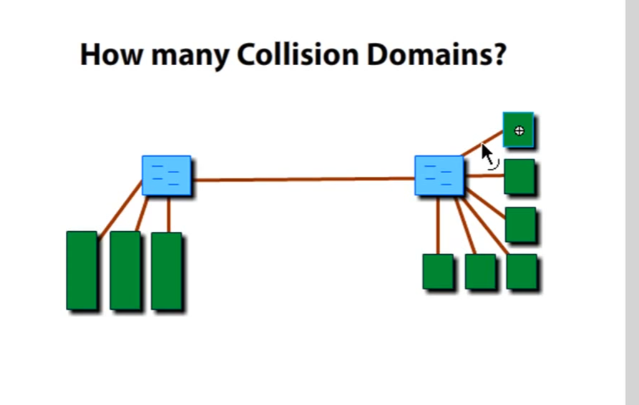

- Assuming the blue squares are switches, and the round circle is a router, how many collision domains?
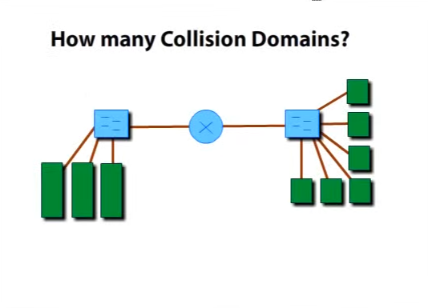

Part 5: 10BaseT
- Explain 10BaseT. What is the naming connection? (e.g., what does 10 refer to, what does base refer to, and what does T refer to)?

- What is half duplex mode and full duplex mode? What is a real life example of both?

- What are some limitations of 10BaseT?

Part 5: 10BaseFL
- Compare 10BaseFL to 10BaseT.

- What are the advantages/disadvantages of 10BaseFL?

Part 6: Extending and Enhancing Ethernet Networks
- What is the trouble with Hubs?

- What are the differences between a switch and a hub?

- What is the Source Address Table?

Applying Your Knowledge
A small company has hired you to solve their networking problem. The wait time to access email is extremely slow, resulting in lowered productivity. The company’s network is an Ethernet LAN, has a bus topology (physical and logical), and uses 10BaseT. The network has 23 devices all connected to the same collision domain. There are three user groups: sales (10 devices), accounting (5 devices), and marketing (5 devices), each with its own server.
The company executives know a little bit about LANs and connectivity devices; however, they do not know whether to purchase a bridge, a hub, switch, or a combination of these devices, and how the network devices should be designed. So they hire you to investigate what’s going on and provide a recommendation.
- Explain the shortcomings of bus topology in this case. Why do you think the emails are so slow? Suggest an alternative topology and defend your choice.
- Explain which devices will help solve their problem (a switch, hub, etc.)
- Using Visio, draw the network configuration you would recommend.

