MIS 423: HoA#1: Part 1
In this assignment, you will explore more about NICs, the physical layer, and the data link layer of the OSI model. Some of this material is adapted from the study guide for the CompTIA Network+ lab manual for Managing and Troubleshooting Networks by Mike Myers.

Network Models and Layers 1 & 2
- What is a network model and what is the overall purpose of a network model?

- Describe layer 1 of the OSI model and its general function. List the hardware that central to this function?

- Describe layer 2 of the OSI model and its general function. What hardware is central to this function?

The NIC and MAC Addresses
- Explain the role of the NIC. What is the MAC Address and its role in networking? At what layers does the NIC operate.

- Using the CMD prompt, please identify your MAC Address. Remember, to do so, type the following into the CMD line and press enter: ipconfig /all

What is your MAC Address (it corresponds to the physical address)? _______________________________________________________

- Identify the network protocols installed for the NIC. On a Windows 10 machine, in the search box on the taskbar at the bottom, type sharing, and then select Manage Advanced Sharing Settings. In the title bar of the Advanced Sharing settings window, click Network and Sharing Center. In the left pane of the new window, click Change Adapter Settings. Last, right-click the Local Area Connection or Wi-Fi icon, and click the Properties menu item.

What items are listed in the This Connection Uses the Following Items section?

- Visit the following website and complete the steps to understand how to diagnose if your NIC card is working properly: http://www.dummies.com/how-to/content/how-to-check-the-network-interface-card-nic-status.html Is your device working properly (yes/no)? ___________

Binary Code and Frames
- In your own words, explain how NICs send and receive data in terms of binary code.

- Label the waveform below in 1s and 0s.
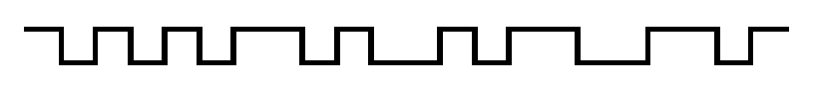

- In your own words, explain what a frame is. Using MS Word shapes (boxes, etc.), label and define the parts of an Ethernet frame.

