Designing WWU’s Network
In this tutorial you will use packet tracker to design a network that is similar to the network of WWU. You will connect PCs and a Server in Parks Hall to PCs in Bond Hall and PCs in Old Main using routers and switches. You will also learn about static routing.

Specifying the Buildings
First, use the drawing tools to the right of the Packet Tracer workspace to draw three circles. These circles will symbolize the buildings the equipment are in. You can color the circles whatever color you want, but make sure they are different colors. After that, please label the circles: (1) Parks Hall, (2) Bond Hall, (3) Old Main. Your screen should look something like this:
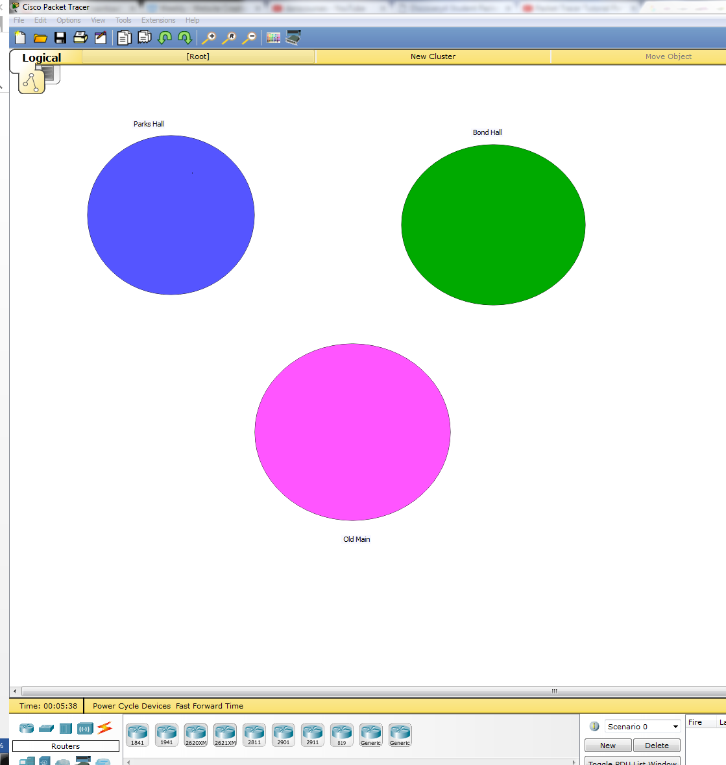

Designing the Network
Configuring the Routers and WAN Interface Card
- Let’s start the network design by adding some routers.
- Drag two 1841 routers in on the inside part of the circles almost touching the border.
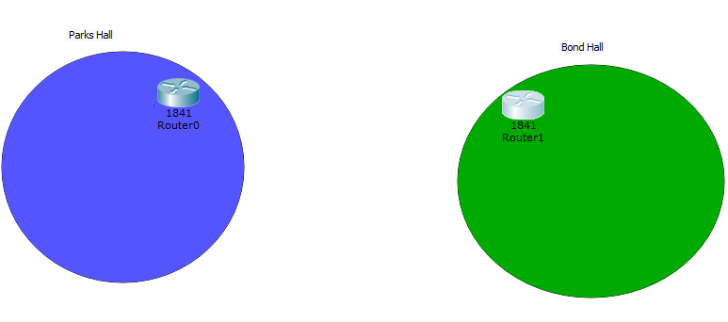
- Now click on the Parks Hall router, Go to Physical
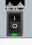
- We need to install a WAN interface card onto the router. To do this, first turn off the router by clicking the power switch and make sure it is off (not green). In the image to the right, the router is on, as indicated by the green light. Click it off.
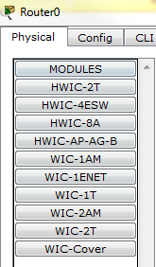
- Next, you should see multiple options on the left side of the screen. These are different choices for a WAN interface card.
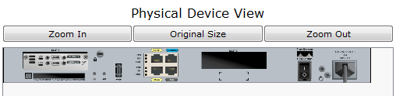
- Drag the WIC-2T button to the rectangle black space on the physical router and place it on the rectangle. This is simulating installing the WAN interface card onto the router. It should look like the picture below.

- Now turn the router back on.
- If you click on CLI, you should see several number signs (or maybe you call them hashtags). This means the software is installing into the router. #networkingrulez
- X out and add the WAN Interface to the Bond Hall router, with a WIC-2T interface.
Connecting the Routers
- Now we need to connect the routers.
- Click on Connections and select Serial DCE
- Attach the cable to the Parks Hall router into the Serial 0/1/0 port, and connect it to the Router for Bond Hall in the same port. Your workspace should look something like this:
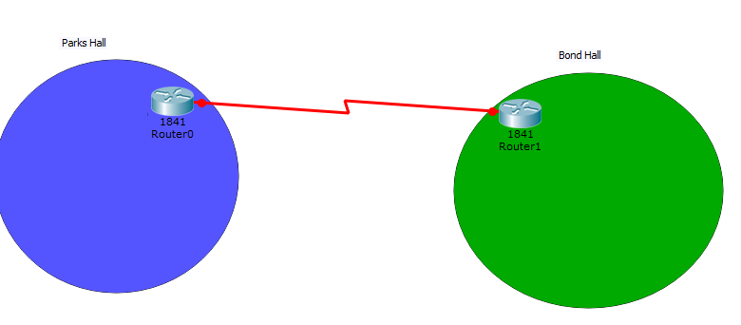
Adding Other Equipment
- Let’s add some other equipment to the buildings.
- First, let’s add a PC; Go to End Devices and add two Generic PCs (PC-PT) in Parks Hall.
- Also add a server to Parks Hall
- Now we want these three devices to be connected to a Switch. So…
- Add a switch to Parks Hall!
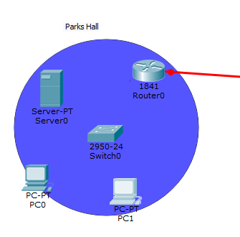
Connecting the Devices
- Let’s connect all of the devices. To make things easier, let’s just automatically let Packet Tracer choose the connection type.
- Click on the Connections Icon and select “Automatically Choose Connection Type.”
- Connect the Router to the Switch
- Connect the Switch to the PCs
- Connect the Switch to the Server
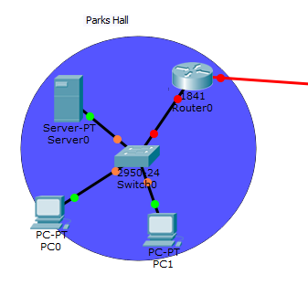
- Now add some equipment to Bond Ball (two PCs and a Switch) and connect the devices.
- Also, Old Main is feeling a bit lonely.
- Add a Router, Switch, and two PCs to Old Main.
- For the Router, select WIC-1T (instead of 2T) so we can see some differences
- In Old Main, connect the Router to the Switch, and the Switch to the Two PCs
- For Bond Hall, Connect the Router to the Switch and the Switch to the Two PCs
- Now, we decide that the most efficient way to route information is to route information through Parks Hall. So, we decide to connect the Parks Hall Router to the Old Main Router, but we don’t want to connect the Bond Hall router to the Old Main Router
- Using the Connections tab, please connect the Parks Hall Router to the router in Old Main

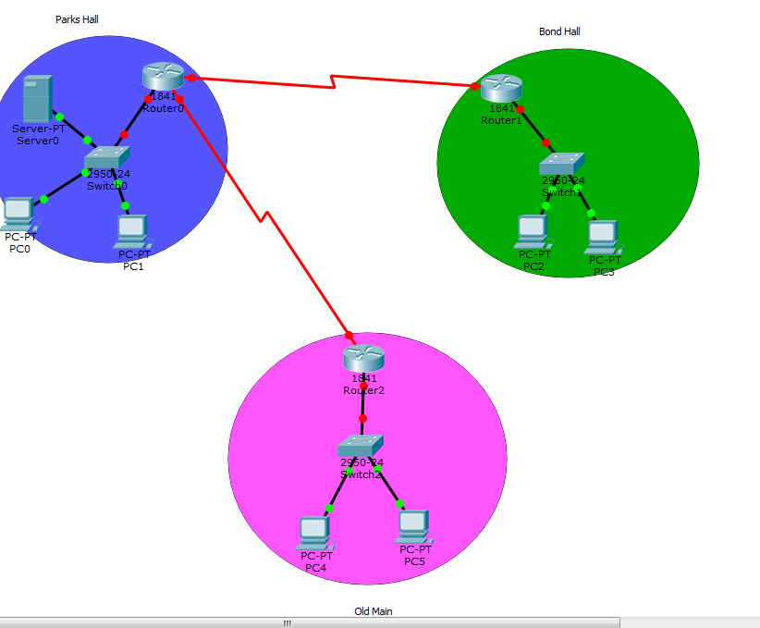
Defining the IPs for the Network/Devices
- Now that we have our connections, we need to map out all the IPs. Before making the connections, let’s make some notes so that we can remember everything. Let’s make some notes to set the IPs for the networks. This is good network design practice!!
- In the Parks Hall circle, make a note for the IP network to be 192.168.10.0
- In the Bond Hall circle, make a note for the IP network to be 192.168.20.0
- In the Old Main circle, make a note for the IP network to be 192.168.60.0
- Over the connection between the Parks Hall and Bond Hall router, make a note for the IP address that reads 192.168.30.0
- Over the connection between the Parks Hall and Bond Hall router, make a note for the IP address that reads 192.168.50.0
- Basically now we have five networks:
  - 192.168.10.0
  - 192.168.20.0
  - 192.168.30.0
  - 192.168.50.0
  - 192.168.60.0
- Your workspace should look like this:
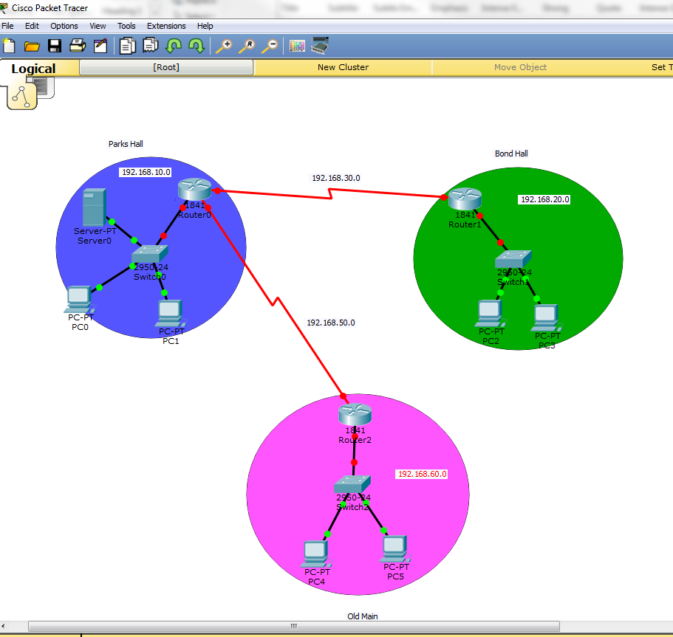

- Now let’s define the IP Addresses for the ports (this will make more sense in a minute)
  - Add a note to the right of the Parks Hall router that reads 30.1
  - Add a note to the left of the Bond Hall router that reads 30.2
  - Add a note to the left of the Parks Hall router that reads 10.1
  - Add a note to the left of the Bond Hall router that reads 20.1
  - Add a note to the middle connection of the Parks Hall router that reads 50.1
  - Add a note to the incoming port of the Old Main router that reads 50.2
- What do you think the note for the port going into Old Main should be labeled as? Remember, the network for Old Main is labeled as 192.168.60.0. Add the note.
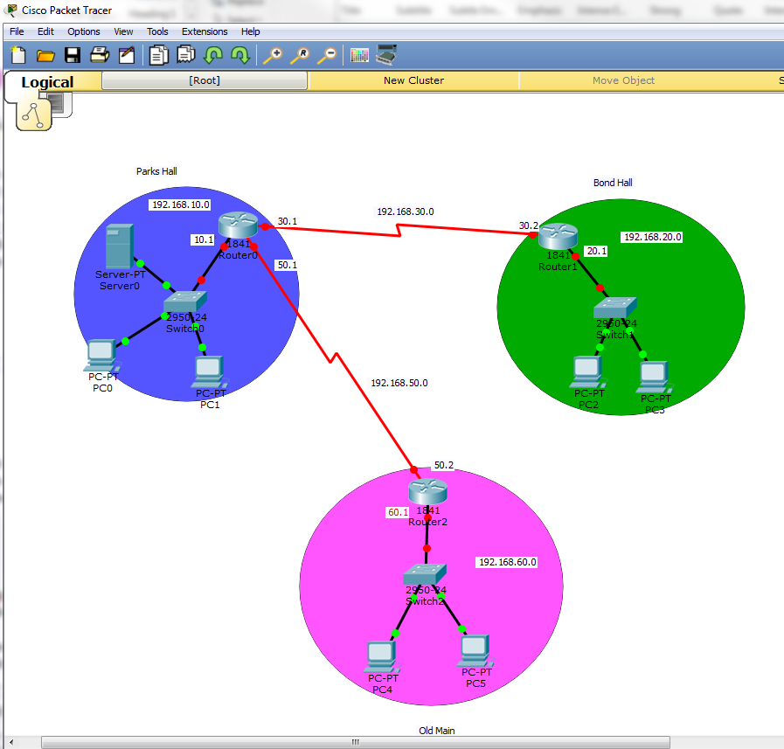
- Now let’s add notes for the IPs for the Server and PCs:
  - Server: 192.168.10.222
  - PC0: 192.168.10.100
  - PC1: 192.168.10.101
  - PC2: 192.168.20.100
  - PC3: 192.168.20.101
  - PC4: 192.168.60.100
  - PC5: 192.168.60.101
Making the IPs Real in Parks Hall (Configuring the Parks Hall Network)
- Now that we have everything mapped out, let’s make this real
- Click on the Parks Hall router, Config,
- Click on Serial0/1/0 (this is the port we selected when installing the WAN interface card). Give it the IP Address of 192.168.30.1 and a subnet mask of 255.255.255.252. Set the Clock Rate of 72000. Turn on the port (upper right hand corner).
  - Also, please notice below that in the GUI interface, at the bottom, there is a window showing you the equivalent IOS commands, which is basically the command line.
- Now for the Bond Hall Router, do the same thing for the Serial0/1/0 port. The IP address is 192.168.30.2 and the subnet mask is 255.255.255.252; clock rate is 72000; Turn the port On
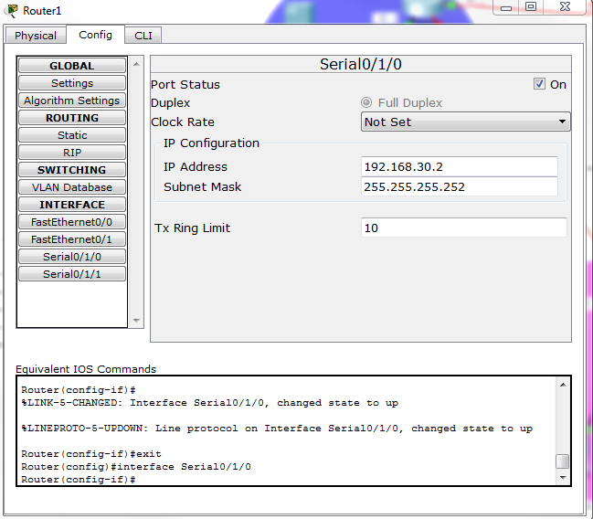
- Ok now that the routers’ ports are on between Parks and Bond Hall, let’s make the other devices connect to each other.
- Click on the Parks Hall Router, Config, and Click on Fast Ethernet0
  - IP address: 192.168.10.1
  - Subnet Mask: 255.255.255.0.
  - Click On in the top right corner of the window. You should see the green circle next to the Router turn on.
- For Parks Hall, assign the IPs to the Server, PC0, PC1 using FastEthernet0.
- Now for the Server and the PCs, go to the IP Configuration module in the Desktop Tab. Assign the Default Gateway the IP Address of the Parks Hall router FastEthernet0 port.
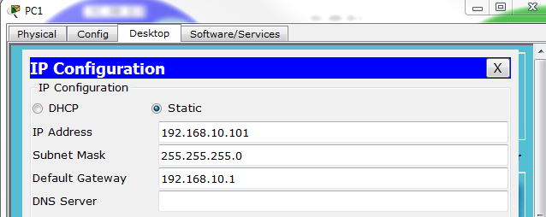
- Everything should now be lit up in green.
- Let’s test it!
- Ping the Server from one of the PCs in Parks Hall. Hopefully you have a successful connection!

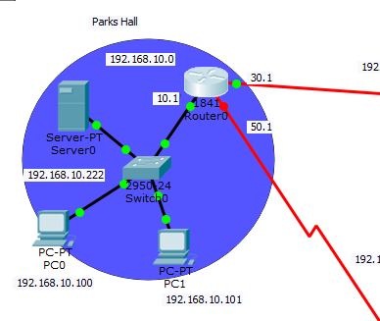

Making the IPs Real in the Other Buildings
- We now need to build the connections for the devices in the buildings and outside the buildings.
- For Bond Hall, do the following:
  - Router: 192.168.20.1 (FastEthernet0); 255.255.255.0; turn it on.
  - PC2: 192.168.20.100; 255.255.255.0
  - PC3: 192.168.20.101; 255.255.255.0
  - Default Gateway for both PCs: 192.168.20.1
- To connect the Parks Hall router to the Old Main router:
  - Click on Parks Hall router, Config, Serial 0/1/1, IP Address 192.168.50.1; 255.255.255.252; Turn it On
  - Click on Old Main router, Config, Serial 0/1/0, IP Address 192.168.50.2; 255.255.255.252; Turn it On
- For Old Main, do the following:
  - Router: 192.168.60.1 (FastEthernet0); 255.255.255.0; turn it on.
  - PC2: 192.168.60.100; 255.255.255.0
  - PC3: 192.168.60.101; 255.255.255.0
  - Default Gateway for both PCs: 192.168.60.1
- Now Test the connections within the buildings by Pinging; Test the connection from one PC in Old Main to the Server in Parks Hall. Connection Unsuccessful, right?? Let’s fix this.
Static Routing
- Let’s do some static routing between the networks; As our networks stand right now, we cannot connect from Parks Hall to Bond Hall, or Parks Hall to Old Main, or Old Main to Bond Hall, etc. This is because the networks are not connected;
- Remember, there are five networks right now, but we need to make them connected. We do this through static routing.
- We need to know the target IP and know the next hop (default gateway)
- Let’s define the static routing for the Old Main Router to the Parks Hall Router.
- Click on the Old Main Router; Config; Routing > Static
  - Network: 192.168.10.0
  - Subnet Mask: 255.255.255.0
  - Net Hop: 192.168.50.1
  - Click Add
- Try to ping a PC from Old Main to the Server in Parks Hall; Still unsuccessful?? WHY??
- We need to make the static routing for ALL of the routers, not just one
- We already defined the Old Main Router, let’s do the others
- For the Parks Hall Router
  - Network: 192.168.60.0
  - Subnet Mask: 255.255.255.0
  - Net Hop: 192.168.50.2
  - Click Add
- Now try to ping from a PC in Old Main to the Server in Parks Hall. Yay!!!!
- That is static routing!!
- Now let’s connect the Parks Hall Network to Bond Hall
- To connect the Parks Hall Router to Bond Hall:
  - Network: 192.168.20.0
  - Subnet Mask: 255.255.255.0
  - Net Hop: 192.168.30.2
  - Click Add
- To connect the Bond Hall Router to Parks Hall:
  - Network: 192.168.10.0
  - Subnet Mask: 255.255.255.0
  - Net Hop: 192.168.30.1
  - Click Add
- Now test the connection from a PC in Bond Hall to a PC in Parks Hall.
- Test a connection from a PC in Bond Hall to a PC in Old Main. NO, NOT AGAIN!! UNREACHABLE! Let’s make that connection happen.
- For the Bond Hall Router
  - Network: 192.168.60.0
  - Subnet Mask: 255.255.255.0
  - Net Hop: 192.168.50.2
  - Click Add
- For the Old Main Router
  - Network: 192.168.20.0
  - Subnet Mask: 255.255.255.0
  - Net Hop: 192.168.30.2
  - Click Add
- Now, try to Ping a PC from Old Main to a PC in Bond Hall. NOOOOOOOOOOOOOO!!!!
- We need to connect the network between Parks Hall and Bond Hall to the Network between Parks Hall and Old Main
- For the Old Main Router
  - Network: 192.168.30.0
  - Subnet Mask: 255.255.255.0
  - Net Hop: 192.168.50.1
  - Click Add
- For the Bond Hall Router
  - Network: 192.168.50.0
  - Subnet Mask: 255.255.255.0
  - Net Hop: 192.168.30.1
  - Click Add
- Now, try to Ping a PC from Old Main to a PC in Bond Hall. SUCCESS!!!
- We have successfully created a network where everyone can talk to each other!
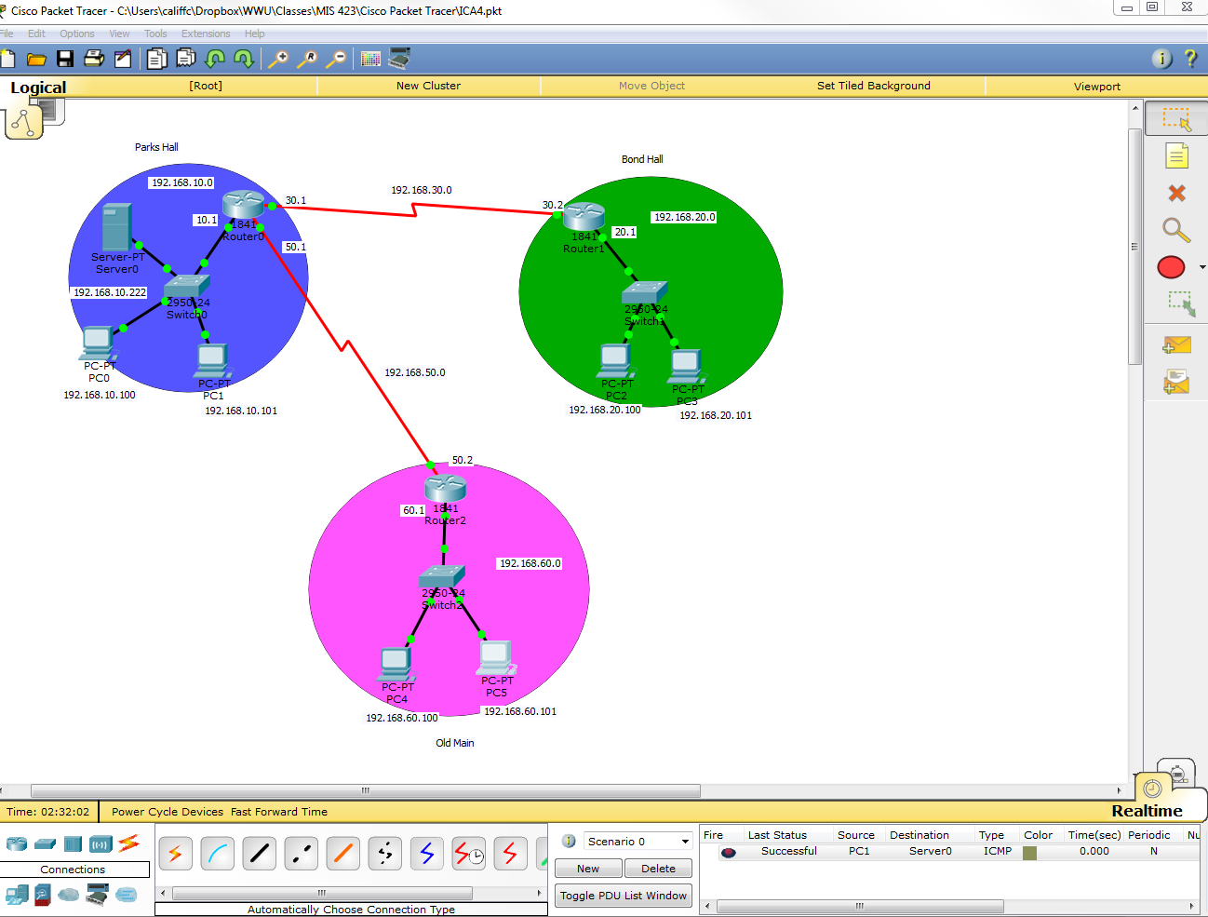

If you would like to learn more about the WIC-2T WAN interface card, place visit the following link: https://www.youtube.com/watch?v=dRA43DaPX5E
For more information about a Serial DCE cable, please visit the following link: http://www.cisco.com/c/en/us/support/docs/routers/7200-series-routers/12219-17.html

